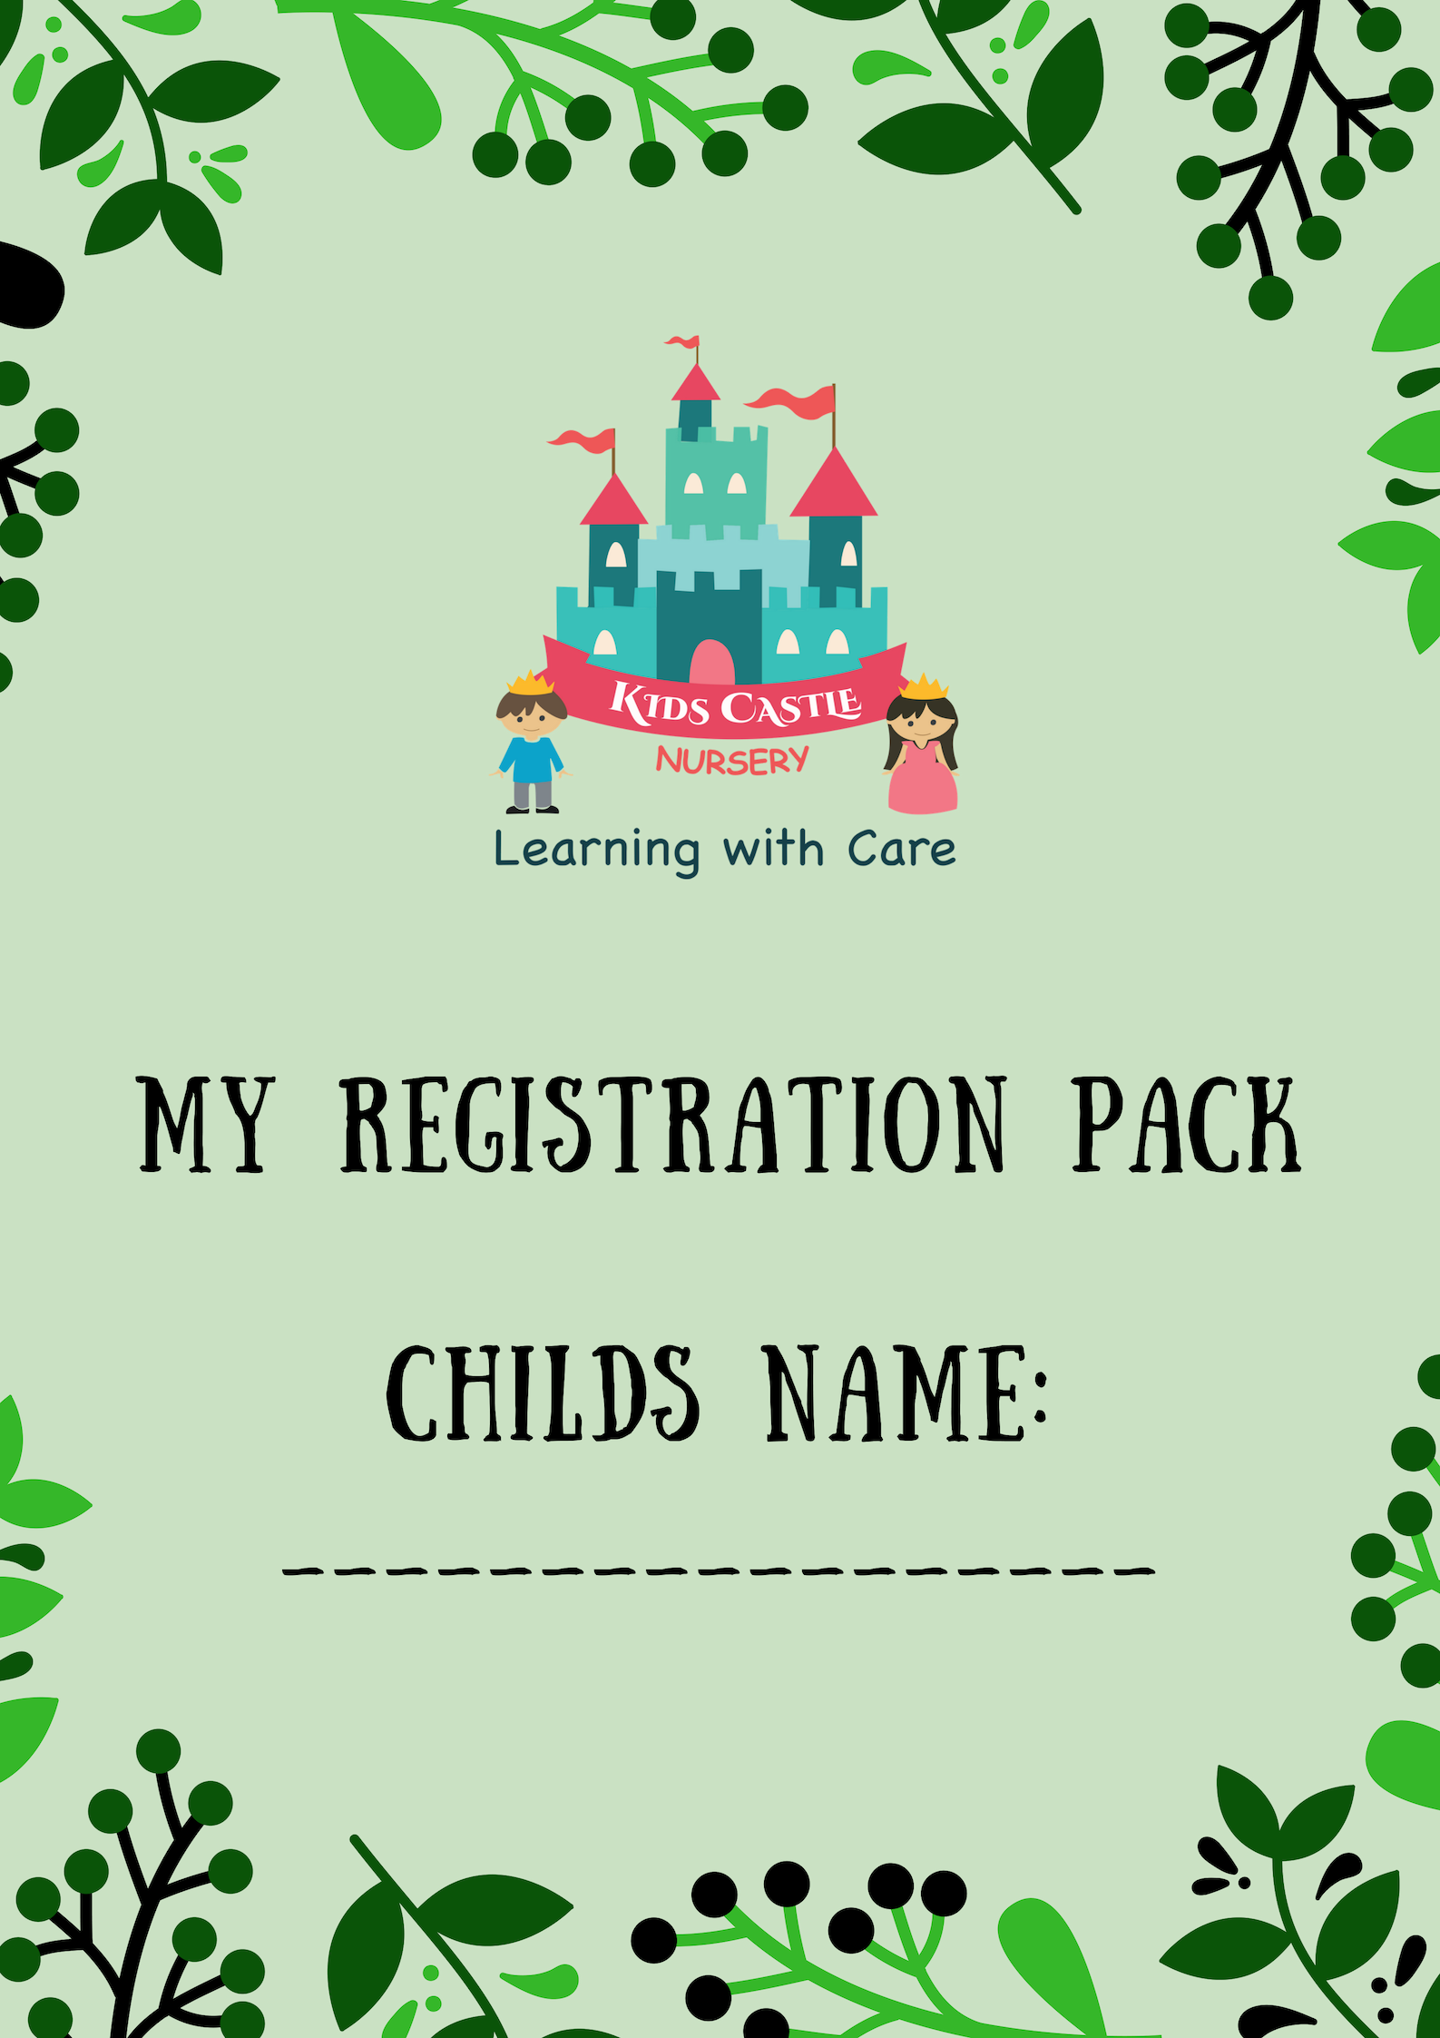

Registration Pack

Child’s Passport Photo

(4 copies)

Mother’s Passport Photo

(2 copies)

Father’s Passport Photo

(2 copies)

|  |  |
| --- | --- |
| Child’s First Name: | Child’s Family Name: |
| I am a: Boy Girl | |
| Date of Birth: DD/MM/YY (Age & Months from September 1st): | |
| Nationality: | |
| Religion: | |
| Languages I Speak: | |
| Siblings(Name/Age): | |
| Previous Nurseries: | |
| Does your child have any allergies? If so, please specify: | |

Child’s Information

Admission Information

|  |  |
| --- | --- |
| Class: | |
| Preferred Days:   * Sunday * Monday * Tuesday * Wednesday * Thursday | Preferred Timings:   * 8.00-12.30 * 8.00-2.00 * 8.00-3.00 * 8.00-4.00 * 8.00-5.00 * 8.00-6.00 * 1.00-4.00 * 1.00-6.00 |

|  |  |  |
| --- | --- | --- |
|  | Mother | Father |
| Full Name |  |  |
| Occupation |  |  |
| Mobile Number |  |  |
| Work Number |  |  |
| Residence Number |  |  |
| Email Address |  |  |
| Place of Work |  |  |
| Address |  |  |

Family Details

Emergency Contact (Apart from parent)

* I/we authorise the nursery to contact the following persons in case of an emergency:

(Parents are contacted first, if we cannot get hold of you, the below will be contacted)

|  |  |  |
| --- | --- | --- |
| Name: | Relationship to child: | Telephone Number: |
| Name: | Relationship to child: | Telephone Number: |
| Name: | Relationship to child: | Telephone Number: |

Allowed to collect (Apart from parent)

Authorised persons to collect my child from nursery – ID Must be provided

* I/we authorise the following persons to collect our child from nursery:

|  |  |
| --- | --- |
| Name: |  |
| Relationship to child: |  |
| Telephone Number: |  |

|  |  |
| --- | --- |
| Name: |  |
| Relationship to child: |  |
| Telephone Number: |  |

|  |  |
| --- | --- |
| Name: |  |
| Relationship to child: |  |
| Telephone Number: |  |

Getting to know your child

Please help us to get to know your child a little more by providing us with some key information.

My Name is:

I like to be called:

My Birthday is:

Language I speak at home:

Nappy Changing / Toileting routine:

Special people in my life:

My favourite toy / objects:

When I am sad I like to:

When I am happy I like to:

Is there anything else you would like to let us know about you or your family?

Photograph & Activity consent form

Do you allow your child to participate in the following activities?

* Child appropriate cooking classes
* Face painting
* Water play (*please note no child is allowed to swim without an appropriate swimming aid)
* Nursery Events/Celebrations
* Birthday Parties

Childs Name:

During our nursery day, we take photographs/videos for a variety of different purposes, mainly to share your child’s experiences with you, the parents.

Please indicate which of the following you give consent to:

* KCN Website
* Nursery Display boards
* KCN Brochure, flyers and other advertising material
* Your child’s assessment book, scrapbook, report, observations and similar.

2. Social Media

* KCN Facebook page

3. May we record your child’s image on video for observation purposes and in school events or special classroom activities (these videos may be posted on our Facebook page for parent viewing)?

* YES
* NO

4. Do you agree to your child being photographed or filmed during promotional events?

* YES
* NO

Please write down any particular routines, sleeping habits (including timings):

My favourite toy is:

My favourite food is:

My favourite drink is:

My favourite song is:

My special days/festivals are:

Medical Agreement

Medical Agreement

**Please note: This form will be given to the school nurse and filed in the Nursery Clinic.**

Name:___________________________________________Date:____________________

Signature_________________________________________________________________

Non-Prescriptive Medication Policy

The school nurse may feel the need to administer the following medicine/products according to manufacturer/physician’s written instructions should it be required. Do you allow the school nurse to administer the following?

* Calpol (Panadol for children)
* First Aid ointment

Sickness policy

KCN aims to provide a safe and healthy learning environment wholly conducive to promotion of healthy practices.

The school Nurse is always on site and is available to discuss your child’s health or offer advice or suggestion.

Please note that children who are unwell or sick cannot remain and should not come into the nursery. In the case that your child becomes unwell at nursery we will call you to come and collect your son/daughter as soon as possible.

Emergency Policy

In the event of an emergency, parents will be immediately contacted.

If the Nursery is unable to contact any of the parents the child will receive First Aid by Nursery staff by Nursery staff and if necessary will be transported to the nearest Health Care Facility to receive emergency care and/or First Aid, with the wellbeing of the child as a priority.

* I/We agree to allow the nursery to adopt the above policy in case of any emergency.

Examination by Physician

The nursery- contracted physician will perform timely examinations on your child, focusing on general health, growth and well- being.

* I/We agree to allow the nursery physician to examine our child.

Medical Consent Form

**Please note: This form will be given to the school nurse and filed in the Nursery Clinic.**

|  |
| --- |
| Child’s First Name: Child’s Family Name: |
| I am a: Boy Girl |
| Date of Birth: DD/MM/YY (Age & Months from September 1st): |
| Name of Doctor & Clinic: |
| Family Clinic Number: |

|  |  |  |
| --- | --- | --- |
| Do you have concerns over your child’s (Please circle): | | |
| Sight | Respiratory Difficulty | Behaviour |
| Hearing | Co-ordination | Movement |
| Speech/Language | Toileting | Learning Difficulty |

Other Information

Special Education Needs

Does your child have any Special Educational Needs? If yes, please provide additional information & any documents to support this:

_________________________________________________________________________________________________________________________________________________________________________________________________________________________________________________________

|  |  |  |
| --- | --- | --- |
| Does your child have: | | |
| Food/other allergies | Any chronic illness | Conditions  requiring special attention |
| If yes to any of the above questions, please provide additional information: | | |
|  | | |

Transp

Transport Form

|  |  |
| --- | --- |
| Child’s First Name: Child’s Family Name: | |
| Parents Name: | |
| Area: | Residential Address: |

Collection from bus

As per the ‘allowed to collect form’ these people will be authorised to collect your child from the bus. (A photocopy of this form will be given to the bus attendant).

In the event of any changes, I agree to inform the centre and submit a revised Transport Form.

Please draw a location map with reference to the closest landmarks:

Helpful indicators of location:

Road Signs/Street Number/Name:________________________________________________________

Landmarks such as mosques/RTA Bus stop/Shops__________________________________________

Name:___________________________________________Date:____________________

Signature_________________________________________________________________

KCN Terms and Conditions

1. Registration fee will be charged one time only and is non-refundable
2. Medical Fee is due once a year
3. AED 1000 will be charged for a withdrawal of the child prior to Academic Year commencing. Remainder of the fees will be refundable.
4. All fees are non refundable.
5. Term fee is due upon registration or at the beginning of each term in full.
6. Medical fees are due upon registration and every year after that.
7. All fees can be paid in cash, cheque or with a credit card (not all branches have card machines)
8. Credit card payments are non-refundable.
9. Term fee will be paid in full or in instalments with post-dated cheques only.
10. All Post-Dated Cheques must be dated 1st of the month.
11. Returned cheques will be charged AED 200.
12. Term fee will be pro-rated after Term has been in progress for over 2 weeks.
13. Term Fee pro-rata basis will be by weeks remaining of the term.
14. Discounted yearly fee must be paid in full upon registration
15. Discounted yearly fee will not be pro-rated if child leaves in the middle of the year.
16. Parents will be responsible to pay the full fees calculated from the beginning of the Academic Year
17. Term Fees do not include Camp time unless you have paid for the ‘camps in included’ option.
18. Partial Term fee will be refunded after a one month notice is given and served in KCN.
19. If parents are not able to give one month's notice, one month's fee will be deducted prior to refund
20. Siblings get a 10 % discount on all Term Fees. Fees such as camps and transportation are not discount
21. Sibling gets an additional 10% discount on the discounted Yearly Fee.
22. Parent who referred a friend whose child joins us for a full term will get an AED 250 discount of the upcoming term.
23. Following documents must be submitted prior to starting date:

* Passport and Visa Copy for the child and both parents
* Emirates ID Copy for the child both parents
* Copy of the vaccination records
* Copy of Birth Certificate
* 4 passport photos of the child
* 2 passport photos of each parent

1. No refunds will be given for holidays, sickness of the child, or sudden closures out of control of KCN.
2. Transportation fee will be added to the Term fees, based on the number of months.
3. During Ramadan period, the timings will change but the fee structure will remain the same, if a child usually attends until 6pm, they will be charged the 3pm fees.
4. Additional charges apply for the early drop off and late pick up of the child.
5. KCN highly discourages parents to come after closing time. AED 50 will be charged for every 10 minutes started after 6pm.
6. The fees are non-transferable.
7. Children and parents are discouraged to bring valuable items into the nursery. KCN will not be responsible for any accidental loss or damage.
8. Registration is subject to re-evaluation by KCN if and when required. The decision of the management is final and will be in best interest of the children within its care.
9. Monthly payments which include term and camp fees need to be paid in 10 PDC dated September 1st until June 1st. Admissions joining after September 30th will have their fees pro-rated.
10. KCN reserves the right to add, modify and/or amend the fee structure, policies and procedures from time to time at its absolute discretion.

**Signatures:** I have received a copy of the prospectus and pricing documents and agree to the conditions contained in them.

Name:___________________________________________Date:____________________

Signature_________________________________________________________________

Declaration Form

I/We hereby agree that Kids Castle Nursery, any members of its staff, supervisors, teachers, assistants, volunteers, helpers or owners of the nursery have no responsibility of whatsoever nature in respect of bodily injury to our child under any on these circumstances:

1. Prior to actual delivery of our child into the custody of the said teachers or officials inside Kids Castle Nursery or after our child has been collected from Kids Castle Nursery by us or a person authorize by us to do so on a normal Nursery Day; or
2. Whist in Kids Castle Nursery before or after the official Kids Castle Nursery timings; or

At any time, unless our child is in the direct custody or control of the said teachers, or on a recognize Kids Castle Nursery outing or Kids Castle Nursery function arranged by Kids Castle Nursery; or

1. Unless the injury is caused by or resulting from:
2. The neglectful act or omission of any employee, teacher or other person or person authorized to act for or on behalf of the Kids Castle Nursery.
3. Any defect on the premises of Kids Castle Nursery.

In Addition, I agree:

1. To indemnity and keep indemnified Kids Castle Nursery and its staff, supervisors, teachers’, assistants or manager, or volunteers or helpers or owners, absolutely harmless fully and effective indemnified against all actions,claims,liabilities,damages,expenses,costs,charges,fees(including medical, judicial, and attorney’s fees) what so ever, which are in respect of any amounts which Kids Castle Nursery may pay, in respect of medical or other expenses arising from accidental bodily injury to our child other than as a set out in 4.
2. To indemnify and keep indemnified Kids Castle Nursery in respect of any loss or damage to property belonging to or in the custody or control of Kids Castle Nursery caused by our child.

I/ We, lawful parents or guardian of the child hereby accepts and agree that in case of an accident or injury occurring to or virus/diseases being contracted by the child, the Director, Nursery Manager, teacher, Nurse or any persons in charge of Kids Castle Nursery, shall have full authority to take the necessary decisions to ensure appropriate emergency medical treatment of my child by the Nursery Nurse of if necessary at a hospital/clinic, if cannot be reached at the emergency numbers.

Name:___________________________________________Date:____________________

Signature_________________________________________________________________

Explanation of Fees

As you have all been made aware upon admission and as per our centres calendar which links in with the majority of nurseries, preschools and schools here in the UAE, our term dates are as follows:

**Term 1:**

**September 2nd 2018 - December 13th 2018**

**Term 2:**

**January 6th 2019 - March 21st 2019**

**Term 3:**

**April 7th 2019 - June 27th 2019**

Our fees (termly and monthly) are split from a 10 month amount. We have made payments easier for parents by splitting this amount into termly and monthly installments. By paying fees monthly you are paying the term fee (as per above dates) split into 3 or 4 payments per term. These monthly fees do not include our camp times, unless you have opted for the 'camps included' option as per our fee structure (attached). We also ask upon admission to hand over a security cheque, which secures your space here with us and we kindly ask that if you leave, that a months’ notice is given prior to your child's departure.

Once your child has joined, our staff will create a learning journey, assessments and observations based on their progress and development here at KCN, this is handed over to every parents when you leave the setting.

When you register at Kids Castle, you are reserving a space for your child which will not be filled by anyone else. If you decide to pull your child out of the setting for a month without notice, your space will be given to another child and parents coming back will be required to pay re-registration upon arrival back at the setting. Re-registration for our regular morning session is AED 750, and afternoon session is AED 750.

If you have any questions regarding the above information, please feel free to contact the centre.

I have read and understood the above ‘explanation of fees’:

Name:___________________________________________Date:____________________

Signature_________________________________________________________________

Documents required to complete registration

|  |  |
| --- | --- |
| Documents | Check |
| Completed and signed registration form |  |
| Photocopy of parent’s passports & residency visa |  |
| Photocopy of child’s passports & residency visa |  |
| Photocopy of child’s birth certificate |  |
| 4 passport photos of child |  |
| 2 passport photos of both parents |  |
| Completed medical record/ Copy of immunisation records |  |
| Emirates ID Copy (Father, Mother, Child) |  |
| Child’s medical insurance copy |  |

For Office Use Only:

Registration Fee Details

Amount Paid …………..……………………… Date Paid………………………………

Medical Fee Details

Amount Paid …………..……………………… Date Paid………………………………

Offer Availed during admissions:

Evidence of Date of Birth [To be obtained from child’s Birth Certificate, Passport or other official evidence of identity and date of birth]

Child’s Date of Birth: …………………………………….…………………………………..

Type of Evidence seen: …………………….……………………………………………….

Checked by (Signature): ………………………………………….. Date…………………….

Other Notes: